Problem 1. “The densest”
Metal X occurs in nature in the form of mineral A. The scheme for obtaining X from A is given below (изб =excess):
By-products are not shown in the above scheme. A solution of sodium carbonate is used in the transformation A→B. A by-product of this reaction is Z, which is insoluble in water. 100 g of A gives 102.05 g of B, which reacts with hydrochloric acid affording 86.78 g of acid C. This C does not contain any water of crystallization. Assume the yields are quantitative for all of the transformations.
  - Identify A-D, Z and X. Support your answers with calculations.
  - Write the equations of the reactions described above.
Х is one of the densest (19.3 g/cm³) elements on Earth. The parameter of its cubic unit cell is 0.316 nm.
  - Which type of unit cell does X have: SC, BCC or FCC? Tick the appropriate box in the Answer Sheet. Support your choice with calculations.
  - Calculate the atomic radius of X r(X), in nm.
The X-based complex H can be synthesized from organic bidentate ligand F, which can be prepared in a one-step transformation from E by the Ullmann reaction.
The molar mass of E is 158 g/mol. E contains 2 different heteroatoms.
The ¹H NMR spectrum of E is given below. There are 5 peaks in the ¹³C NMR spectrum of E.
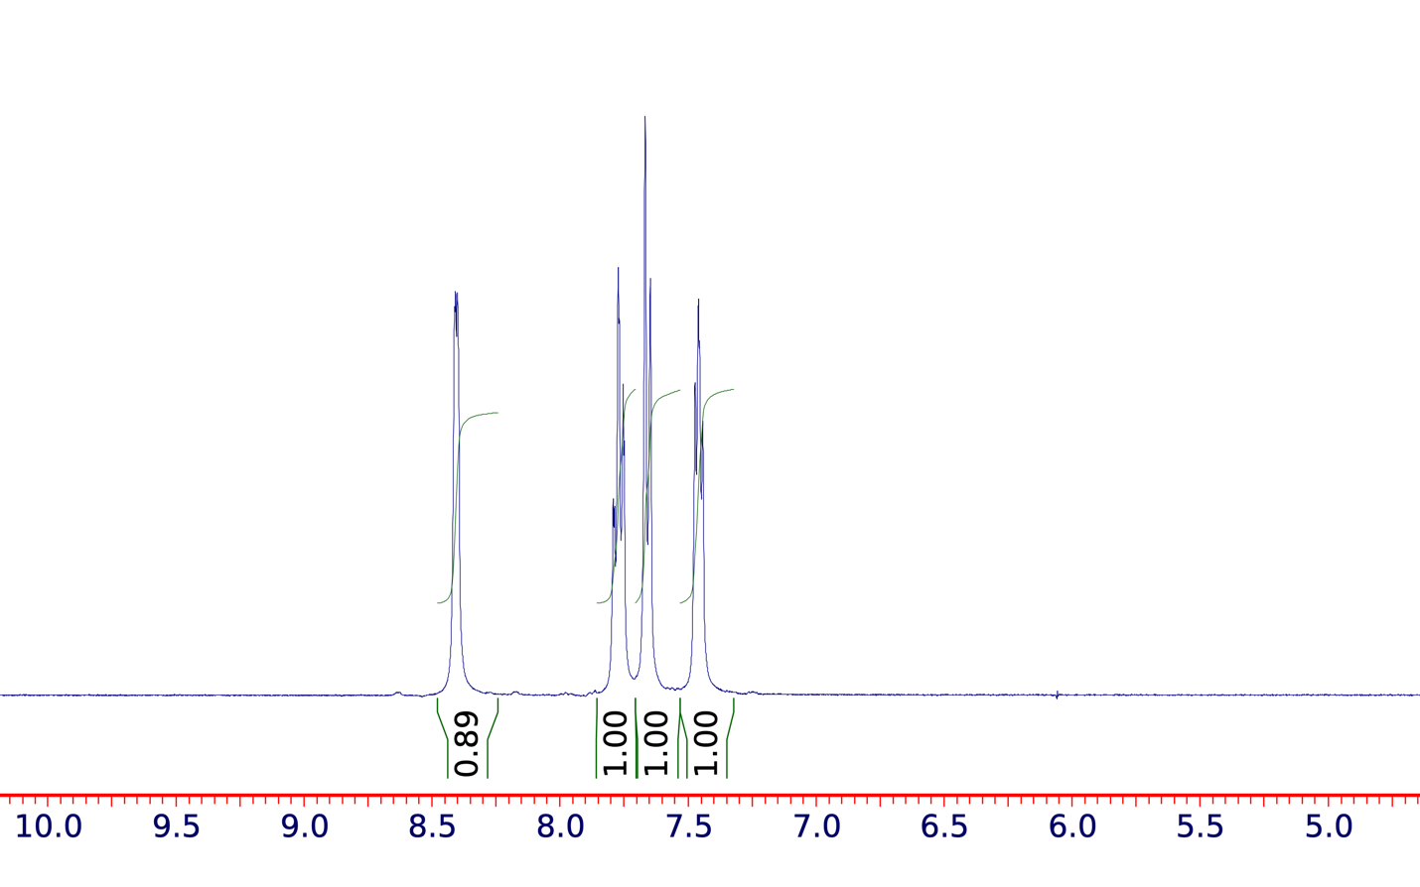
¹H NMR of E
  - Identify the molecular formula of E.
The ¹H NMR spectrum of F is given below. There are 5 signals in the ¹³C NMR spectrum of F.
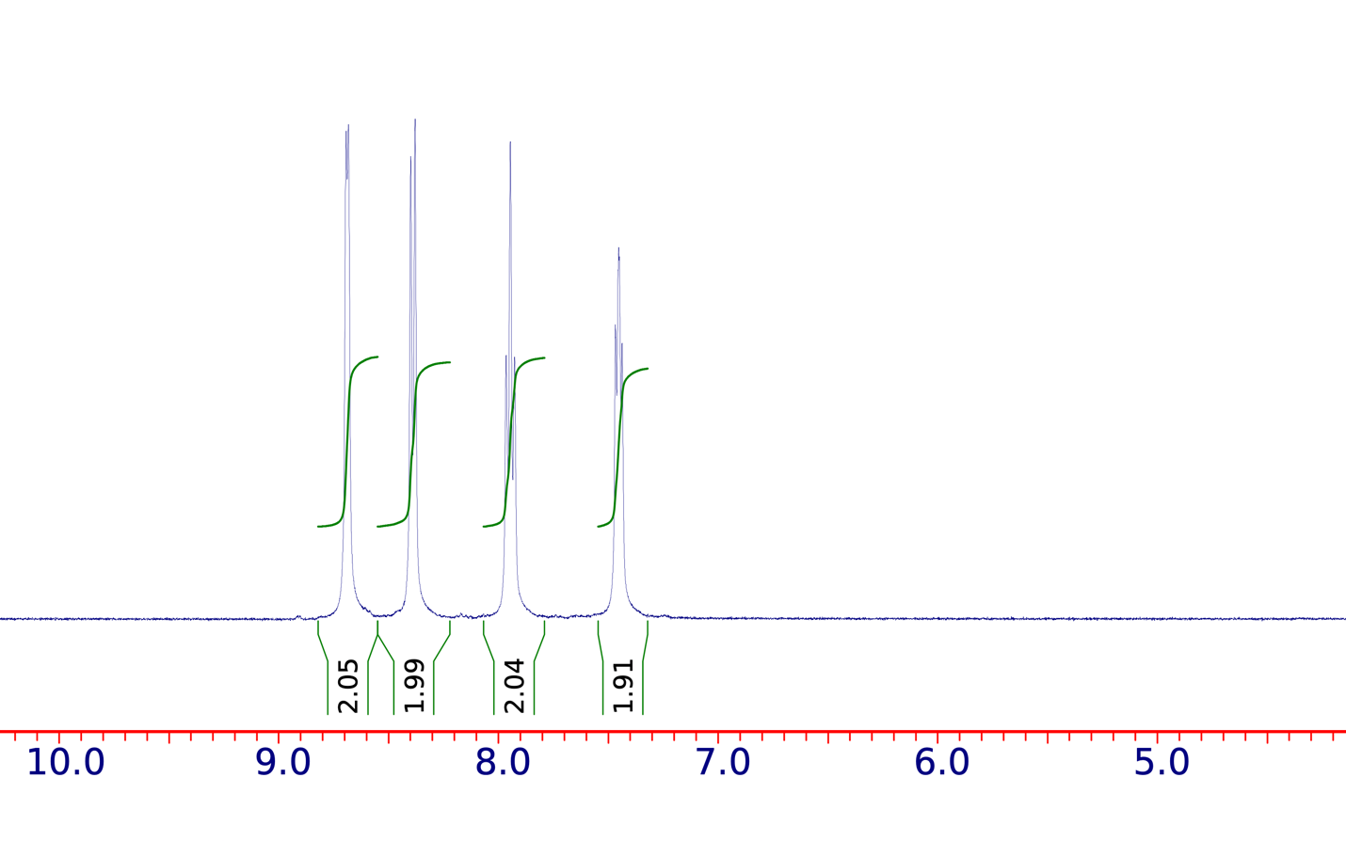
¹H NMR of F
  - Draw the structural formulas of E and F.
When ligand F is heated with precursor G in a sealed ampule, complex H is obtained as the only product that contains X. G is a carbonyl complex of X. In the transformation G→H, approximately 30% of the ligands are exchanged.
The “18-electron rule” states that complexes of transition metals are most stable when the sum of their valence electrons is 18.
  - Identify G using the “18-electron rule”.
Interestingly, H does not show optical activity and has a non-centrosymmetric spatial symmetry, which allows it to be applied in piezoelectric materials and lasers.
  - a) Write the reaction equation for the synthesis of H and b) draw its molecular structure. You may use the abbreviation for ligand F shown below.

Problem 2. Radioisotope dating
In 2003, quite by chance, a Hellenistic-era monument (Kurganzol fortress) was discovered in the Surkhandarya region of Uzbekistan. In 2008, archaeologists conducted radiocarbon dating of the wood from Kurganzol. After collecting all the archaeological data, scientists concluded that Kurganzol was built in 328 BC after the conquest of Central Asia by Alexander the Great.
  - The radiocarbon dating method is based on the β-decay of the isotope ¹⁴C (t_{1/2} = 5700 years). Write the equations of reactions for a) β-decay of the isotope ¹⁴C, and b) its formation in an atmosphere from ¹⁴N under the action of neutrons.
  - During the life of plants and animals, the concentration of ¹⁴C remains constant due to exchange with the environment, while after death it starts decreasing according to first order kinetics. Calculate the specific activity (Bq per 1 kg of carbon) of wood from Kurganzol in 2008, if this activity in the atmosphere is equal to 226 Bq per 1 kg of carbon.
  - The content of ¹⁴C in the atmosphere is influenced by Solar activity, changes in the Earth's magnetic field, and anthropogenic factors (burning of organic fossil fuels, nuclear tests). Match the fifty-year periods (1850-1900, 1900-1950 and 1950-2000) with the graphs of changes in the specific activity of ¹⁴C in the atmosphere:
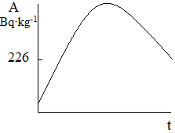 | 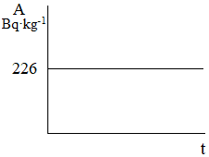 | 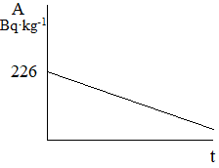
picture А | picture В | picture С
Muruntau is one of the largest gold deposits in the world. It is located in the Muruntau Mountains, in the southwest of the Kyzylkum desert, in the Navoi region of Uzbekistan. Scientists estimate the age of the deposit by decay: ⁸⁷Rb = ⁸⁷Sr + $β^{-}$ + $\overline{v_{e}}$, t_{1/2} = 48.81⸱10⁹ years. The composition of the rocks at the time of formation includes unknown amounts of radioactive ⁸⁷Rb and stable isotopes ⁸⁷Sr, ⁸⁶Sr. Consider that the initial ratio ⁸⁷Sr/⁸⁶Sr was the same all over the rocks, while the initial ratio ⁸⁷Rb/⁸⁶Sr was different in various places of the rocks.
  - Match the isotopes ⁸⁷Rb, ⁸⁷Sr and ⁸⁶Sr with the graphs below, which show the dependence of the number of nuclei (N) on time (t):
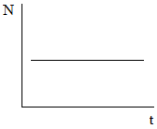 | 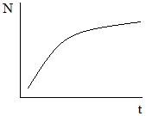 | 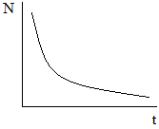
picture D | picture E | picture F
  - Using the isotope ratios currently shown in different samples, calculate the age (t, years) of the Muruntau gold deposit:
 | ⁸⁷Sr/⁸⁶Sr | ⁸⁷Rb/⁸⁶Sr
Sample 1 | 0.780 | 18.5
Sample 2 | 0.716 | 2.0

  - Calculate the initial ratio of isotopes ⁸⁷Sr/⁸⁶Sr and ⁸⁷Rb/⁸⁶Sr at the time of formation of the Muruntau rock in samples 1 and 2 (s1 and s2).
Meteorites are often considered as residual material from the formation of the solar system. If so, the age of meteorites is equivalent to that of the Earth. In 1953, Claire Patterson took samples from several meteorites and obtained the first relatively accurate estimate of the age of the Earth. He measured the content of three isotopes of lead (²⁰⁴Pb, ²⁰⁶Pb and ²⁰⁷Pb) in meteorites:
Meteorites | ²⁰⁶Pb/²⁰⁴Pb | ²⁰⁷Pb/²⁰⁴Pb
Nuevo Laredo, Mexico | 50.28 | 34.86
Canyon Diablo, Arizona | 9.46 | 10.34

  - One of the isotopes is not involved in the process of radioactive decay, while the other two are the decay products of the isotopes ²³⁵U (t_{1/2} = 0.704⸱10⁹ years) and ²³⁸U (t_{1/2} = 4.47⸱10⁹ years). Determine which isotopes of lead are the final products of the decay of ²³⁵U and of ²³⁸U, respectively. Note that the radioactive series consists only of α- and β-decays.
  - Considering that the ratio of lead isotopes in both of the above meteorites at the time of their formation was the same, and the present ratio of uranium isotopes in them is ²³⁸U/²³⁵U = 137.88, calculate the age of the Earth (in years). Consider that the Earth and meteorites formed at the same time. Show your calculations and tick the nearest answer in the Answer Sheet.

Problem 3. Natural source of "brown carbon"
α-Pinene is emitted by vegetation with emissions of about 66×10¹² g/year and is the main source of secondary organic aerosols (SOA). After emission, α-pinene can react with O₃, •OH or •NO₃ in air, which leads to the formation of multifunctional organic compounds containing carbonyl, carboxyl, hydroxyl, peroxide and other functional groups. Then, under the action of aerosol acid, the products degrade to form "brown carbon", which includes compounds capable of absorbing visible and near ultraviolet radiation, thus leading to deterioration of visibility and air quality with a negative impact on the regional climate.
  - Sulfuric acid in the air is mainly formed from SO₂, O₂ and H₂O in troposphere via •OH and other intermediates. Write a) the overall reaction and b) the reactions of 4-step formation of sulfuric acid from SO₂.
To determine and study SOA, α-pinene was subjected to ozonolysis and the products (A and B) were passed through LC-MS (liquid chromatography-mass spectrometer). While the liquid chromatography separates mixture of compounds based on time between the injection of a sample and its elution from the column (retention time t, specific for each compound), the mass-spectrometer analyzes the molecular weight (M_{w}) of every peak in real time. The following data were obtained: A [M_{w}] 184.11 (t = 8.95 min), B [M_{w}] 168.11 (t = 9.77 min).
  - Draw the structural formulas of A and B with correct configuration.
To study the degradation of ozonolysis products, A and B were each placed in a separate sulfuric acid solution. Analysis of the solution of A in 5.6 M sulfuric acid after 2 days showed 3 signals with [M_{w}] 184.11 in LC-MS: A (t = 8.95 min), C (t = 9.05 min), D (t = 8.78 min). Only one signal (184.12 (t = 8.78 min)) was detected for the solution of A in 10 M H₂SO₄. The mechanism of formation of D (Homoterpenyl methyl ketone) is shown below (H⁺ transfers are avoided for brevity):
  - Draw the structures of intermediates I-1 and I-2 and the compound C, if [I-1] is a tertiary carbocation and C has two stereogenic centers.
However, none of the formed substances showed absorption of UV light. Analysis of the solution of B in 10 M H₂SO₄ revealed 4 signals [M_{w}]: D 184.12 (8.78 min), E 150.1 (11.85 min), F 150.1 (12.07 min), G 150.1 (12.22 min), the latter three signals showed strong absorption of UV light. Researchers isolated two of them (E and G) individually. The structures of the compounds were analyzed by 1D, 2D NMR and hydrogenation reactions.
  - Calculate the degree of unsaturation (D.U. – the total number of π-bonds and cycles) of E–G.
The data obtained from ¹H and ¹³C NMR spectra and their correlations with 2D NMR data for fragment 1 of E are given below (Table shows relation of ¹H NMR signals (row 2) attached to the corresponding carbon atoms (row 3), and the 1st and 2nd order neighboring carbon/hydrogen signals (row 4) within the column):
Relative intensity | 1H | 2H | 3H | – | –
δ, ppm, ¹H | 7.16 | 2.63 | 2.33 | – | –
δ, ppm, ¹³C | 140.9 | 29.3 | 26.7 | 146.3 | 197.1
The 1st and 2nd order neighboring carbon/hydrogen signals | 197.1  146.3  29.3 | 140.9  133.1  140.5 | 197.1  146.3 | 7.16  2.33  2.53 | 7.16  2.33
  - Draw the structure of fragment 1, based on the NMR data.
Similar data for fragment 2 are given below:
Relative intensity | 2Н | 3Н | 3Н | – | –
δ, ppm, ¹H | 2.53 | 1.87 | 1.74 | – | –
δ, ppm, ¹³C | 27.8 | 21.5 | 22.0 | 133.1 | 140.5
The 1st and 2nd order neighboring carbon/hydrogen signals | 146.3  133.1 | 140.5  133.1  22.0 | 140.5  133.1  21.5 | 2.63  2.53  1.87  1.74 | 1.87  1.74
  - Draw the structure of fragment 2, based on the NMR data.
  - Draw the structure of E.
  - E and G give the same product when hydrogenated. Draw the structure of G if the following ¹H NMR data are known for it: 7.24 (d, 1H), 6.22 (d, 1H), 3.22 (s, 2H), 2.72 (m, 1H), 2.32 (s, 3H), 1.14 (d, 6H).
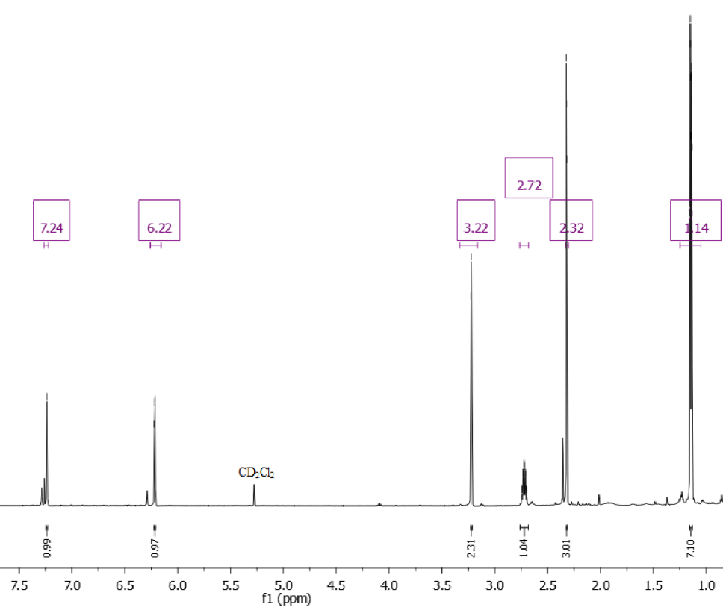
According to an alternative theory, the products of α-pinene ozonolysis degrade due to •OH radicals in aerosols. In another study, researchers placed compound A in a H₂O₂ solution and irradiated it with light. Analysis of the products showed the following distribution (the molecular weight and molar fraction in parentheses are given under the designations of the products):
  - Draw the structures of Н–М without stereochemistry. Suggest two possible structures for K that are not stereoisomers.
Additional information:
All compounds are chiral. Each of H–J has 2 asymmetric carbon centers, while K has 3. L and M are esters containing 4 asymmetric carbon centers each.
The formation of J can be described as a stepwise transformation: А→H→I→J.

Problem 4. The Many Faces of Arsenic: A Redox Journey
The Latimer diagram for arsenic in an acidic environment (pH = 0, T = 298 K) is shown below; the values of the standard electrode potentials are in volts (V) relative to the standard hydrogen electrode:
4.1. Write the reduction half-reactions for the a) H₃AsO₄/As and b) H₃AsO₄/AsH₃ pairs in an acidic environment.
4.2. Determine the values of Е°₁ and Е°₂ in V.
4.3. Do the a) H₃AsO₄/As and b) H₃AsO₃/AsH₃ pairs undergo comproportionation at pH = 0? Write the corresponding reaction equation and justify your answer with calculations. Tick “Y” if the reaction is spontaneous and “N” if it is non-spontaneous.
4.4. The electrode potentials of some redox pairs depend on pH. a) Derive the dependence of the electrode potential for the As/AsH₃ pair ($E_{As/AsH_{3}}$) on pH. b) Calculate the electrode potential (V) of this pair at pH = 14.
A Pourbaix diagram represents the zones of the most stable species in E–pH coordinates. At the boundaries separating these zones, the concentrations of the bordering species are equal. The Pourbaix diagram for arsenic is shown below:
E, V | 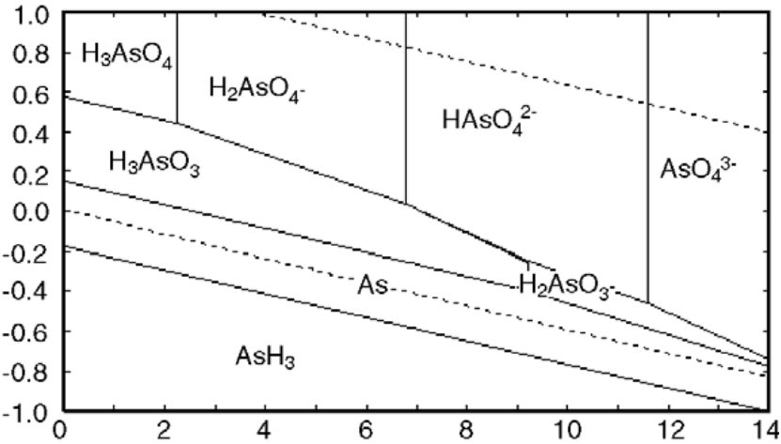
 | pH
4.5. Determine the рK_{а}(Н₃AsO₃).
4.6. For the half-reaction I₂ + 2e⁻ → 2I⁻, the standard electrode potential E°(I₂/I⁻) = 0.536 V. Calculate the pH value(s) at which an H₃AsO₄ solution can oxidize I⁻.
Arsenic(III) oxide was once used as a poison. It was believed to be undetectable in the body until the development of the Marsh test. To detect the presence of arsenic, the test sample is placed in a tube with 4 M sulfuric acid, and metallic zinc is added to the resulting solution. The released gas is passed through a hot glass tube. A mirror-like deposit of substance X forms if arsenic is present in the sample.
4.7. Using the Pourbaix diagram, determine the species Y to which H₃AsO₃ is reduced in the Marsh test, given that E°(Zn²⁺/Zn) = −0.76 V.
4.8. Identify X. Write the reaction equations for a) reduction of H₃AsO₃ and b) formation of X.
Copper(II) sulfate is added to accelerate the Marsh test. Interestingly, the product of H₃AsO₃ reduction (determined in 4.7.) can be re-oxidized to AsO₄³⁻ in an alkaline medium (pH 14) with a saturated solution containing an excess of Cu(OH)₂(s) in the reverse Marsh reaction.
4.9. a) Write the ionic equation for the reverse Marsh reaction. b) Calculate its equilibrium constant K. Provide your calculations. Use the following data in your calculations:
Cu²⁺ + e⁻ → Cu⁺ | E°(Cu²⁺/Cu⁺) = 0.153 V
Cu(OH)₂ ⇌ Cu²⁺ + 2OH⁻ | K_{sp}(Cu(OH)₂) = 4.8⸱10⁻²⁰
Cu₂O + H₂O ⇌ 2Cu⁺ + 2OH⁻ | K_{sp}(Cu₂O) = 4.0⸱10⁻³⁰
H₂O ⇌ H⁺ + OH⁻ | K_{w} = 1.0⸱10⁻¹⁴

Problem 5. Water and the Aral Sea
Water is one of the most important compounds on the Earth. Transition from one state to another ensures circulation of water.
The standard gas phase thermochemistry data of $H_{2}O(l)$ and $H_{2}O \left(g\right)$ are shown below. ∆fH° and S° do not depend on the temperature.
 | $$H_{2}O(l)$$ | $$H_{2}O (g)$$
$$∆_{f}H°/(kJ mol^{-1})$$ | -285.8 | -241.8
$$S°/(J mol^{-1} K^{-1})$$ | 69.95 | 188.8

  - Using the values from the table and assuming that enthalpies and entropies do not depend on temperature, determine: a) the boiling point (K) of water at a pressure of 1 bar; b) the vapor pressure of water (Torr) at 298 K.
Water is one of the components of clouds, which under certain conditions create rain or snow. An air mass moving across the ocean at a height of 2000 m encounters a coastal mountain range. Rising to 3500 m to pass over the mountain, it undergoes a reversible adiabatic expansion. The pressures at 2000 m and 3500 m are 0.802 atm and 0.602 atm, respectively.
  - If the initial temperature of the cloud mass is 288 K, what is the temperature (K) of the cloud as it passes over the mountains? Consider air as an ideal gas with
$C_{p,m}=28.86 J K^{-1}mol^{-1}$

An air mass can form clouds if its temperature reaches the dew point. The formed clouds can further cause rain or snow. Dew point T_{d} is defined by the formulas:
$$γ\left(T,RH\right)=\ln\left(\frac{RH}{100\%}\right)+\frac{bT_{0}}{c+T_{0}}$$
$$T_{d}=\frac{c*γ(T,RH)}{b-γ(T,RH)}$$
where b = 17.625 and c = 243.04 °C, T₀ is the initial temperature of air mass in °C. The relative humidity (RH) at this range of altitudes is 50%. For clouds to form, the air mass temperature (T) must be equal to or lower than the dew point temperature.
  - Calculate the dew point temperature (ºC) for the air mass at the altitude of 2000 m. Do clouds form at this altitude? If so, circle “Y”, if not, circle “N”.
  - a) When the air mass raises over the mountains, should you expect cloud formation? If so, circle “Y”, if not, circle “N”. T₀ is the same as in 5.3.
b) If you have chosen “Y” above, decide whether any precipitation would be rain (circle “R”) or snow (circle “S”).
A fascinating meteorological phenomenon called “freezing rain” occurs under specific temperature conditions when a layer of warm air sits above a cold surface. High in the clouds, precipitation begins as snow because the temperature is below 0°C. As the snowflakes fall through a warmer layer of air, they melt and turn into raindrops, which then pass through a cold layer of air near the ground with the temperature below freezing. However, the raindrops remain in the liquid state due to the absence of ice nucleation. When the supercooled raindrops reach the ground or any cold surface, they freeze instantly, forming a layer known as glaze ice creating hazardous conditions.
Suppose it starts snowing in the clouds at the temperature of –10°C (1). Then, the snow passes through warm layer of air at the temperature of +3°C and becomes liquid (2). The liquid passes through cold air mass with –5°C but remains liquid (3), and then touches the surface and freezes instantly without changing temperature (4).
  - Write a scheme that shows the above mentioned transitions (1-4) occurring with freezing rain. Clearly indicate the temperature and phase of the water.
  - Calculate the entropy change (J) in the entire process 1 → 4 for 1 mole of water. Assume that heat capacities do not depend on temperature. Assume that all the processes are isobaric and p = 1 atm. Data can be found in the Additional information section.
Drying up of the Aral Sea is one of the ecological tragedies that has happened in Central Asia. It affected not only the surrounding areas but also distant places on our planet. The level of one of the parts of the Aral Sea, which is referred to as the Great Aral, was analyzed using a satellite between 1993-2008. The data are presented in the table below:

Year | Level (m)
1993 | 36.98
1994 | 36.36
1995 | 35.75
1996 | 35.14
1997 | 34.55
1998 | 33.97
1999 | 33.40
2000 | 32.84
2001 | 32.29
2002 | 31.74
2003 | 31.21
2004 | 30.68
2005 | 30.17
2006 | 29.66
2007 | 29.16
2008 | 28.67

Assuming a constant temperature, the change in level occurs similarly to chemical reactions and proceeds as a first-order reaction.
  - Plot the data from the table as the linear graph corresponding to first-order kinetics on the provided space in the Answer Sheet. Calculate the rate constant for the change in the level of the Great Aral. Pay attention to the units used.
  - The Aral Sea and the Great Aral started drying out in 1960s. Calculate the level (m) of the Great Aral in 1960 if that the first-order tendency applies to the whole period of drying up.
  - If the level continues to change in the same way, when (which year) will the Great Aral completely dry out? Take the residual level of 2 m as an equivalent of complete drying out.
Additional Information:
For the reversible adiabatic process: pV^{γ} = const, γ = c_{p/}c_{v}
For the ideal gas, c_{p} = c_{v} + nR
For phase transition: $∆S=\frac{∆H_{transition}}{T}$
Entropy change at constant pressure: $∆S=nC_{p}ln⁡(\frac{T_{2}}{T_{1}})$
$C_{p,m}\left(H_{2}O_{s}\right)=37.94 J mol^{-1} K^{-1}, C_{p,m}\left(H_{2}O_{l}\right)=75.32 J mol^{-1} K^{-1}$
$∆H_{fusion}\left(H_{2}O\right) at 273.15 K=6020\frac{J}{mol}$

Problem 6. Functional peptides
Part A
Today, there is particular interest in opioid peptides (hereinafter referred to as OPs) as a group of bioregulatory molecules with diverse effects on the human body (although analgesic effects undoubtedly predominate). Information about OPs A, B, C, D, and E is given in the table below. All five OPs are composed exclusively of residues of neutral canonical amino acids (a residue is the part of an amino acid remaining after amide bond(s) formation).

Peptide | Number of amide bonds | Total number of amino acid residues | Number of residue types | Molar mass (g/mol) | Total number of atoms
A | 4 | 5 | 4 | 555.62 | 77
B | 4 | 5 | 4 | 573.67 | 75
C | 4 | 5 | 4 | 594.66 | 79
D | 4 | 4 | 4 | 610.71 | 83
E | 4 | 4 | 3 | 571.67 | 79

A and B have similar amino acid sequences and thus act on the same receptors, as do D and E.
D and E are formed from pentapeptides D1 and E1, respectively, via similar reactions catalyzed by the same enzyme. The biosynthesis equation for D is:
D1 + ½ O₂ → D + O=C(H)-COOH
6.1. a) Determine at least one amino acid that is definitely present in D1 and E1;
b) is it possible to determine the position of this amino acid? If so, circle “Y”, if not, circle “N”;
c) if you circled “Y” above, indicate the position (counted from the N-terminus).
6.2. Draw the polypeptide backbone of D. Show side chain substituents as R.
6.3. Using the data from the above table, determine without determining the structures of A-E:
a) the OP, which has a sulfur-containing amino acid in its structure;
b) whether there is more than one residue of the sulfur-containing amino acid in this peptide; if so, circle “Y”, if not, circle “N”;
c) the OP for which at least one amino acid (AA) in its composition can be unambiguously identified.
6.4. Using the above data and mathematical reasoning, decipher the amino acid composition of any OP without exhaustive search. Confirm your answer with calculations.
Reference information for neutral canonical amino acids.
Amino acid | Molecular formula | Molar mass (g/mol) | Amino acid | Molecular formula | Molar mass (g/mol)
Ala | С₃H₇NO₂ | 89,098 | Pro | С₅H₉NO₂ | 115,132
Asn | С₄H₈N₂O₃ | 132,119 | Ser | С₃H₇NO₃ | 105,093
Val | С₅H₁₁NO₂ | 117,147 | Thr | С₄H₉NO₃ | 119,120
Gly | С₂H₅NO₂ | 75,067 | Tyr | С₉H₁₁NO₃ | 181,191
Gln | С₅H₁₁N₂O₃ | 146,146 | Trp | С₁₁H₁₂N₂O₂ | 204,228
Ile | С₆H₁₃NO₂ | 131,174 | Phe | С₉H₁₁NO₂ | 165,191
Leu | С₆H₁₃NO₂ | 131,174 | Cys | С₃H₇NO₂S | 121,154
Met | С₅H₁₁NO₂S | 149,207

Part B
One of OPs with the general formula H₂N-Q-Met-COOH is found in mammals. The fragment Q is a tetrapeptide, which consists of 3 different canonical amino acids. The following steps were done to determine the sequence of Q:
Step 1. Ph-NCS is used to identify N-terminal amino acid:
The release of Z was identified by mass spectrometry which showed [M+H⁺] =299.37.
Step 2. The remaining peptide reacts with 1-fluoro-2,4-dinitrobenzene which binds to the amino group at the N-terminus giving a yellow compound, which is then hydrolyzed with 6 M HCl. Next, the resulting solution is analyzed by TLC chromatography and visualized:
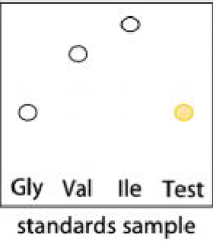
6.5. Find the structural formulas of X, Y, and Z. Take into account that recyclization occurred in the transition from Y to Z.
6.6. Identify the amino acid that reacted with 1-fluoro-2,4-dinitrobenzene.
Under full-scan analysis, the mass spectrum was dominated by the protonated molecular ion [M+H⁺] for H₂N-Q-Met-COOH, m/z 574.20, while the most intense fragment (m/z 120.19) corresponds to an immonium ion.
6.7. Draw the structure of the cation with the mass 120.19, if it is formed by release of a gas from the immonium form of the amino acid.
6.8. Determine the amino acid sequence of the tetrapeptide, if there is a peptide bond formed between two residues of the same amino acid. Show the -NH₂ and -COOH terminal groups.

Problem 7. Legends about X
According to a legend, one reason why Napoleon’s army struggled in the Battle of Borodino is connected with the buttons on French soldiers’ coats, which were made of a silver-white metal X. X exists in two allotropes: α-X, which is brittle, and β-X, which is malleable. At room temperature, β-X is stable, but at very low temperatures, it transforms into α-X and can crumble into powder.
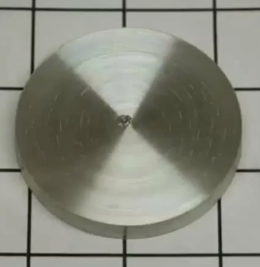 | → | 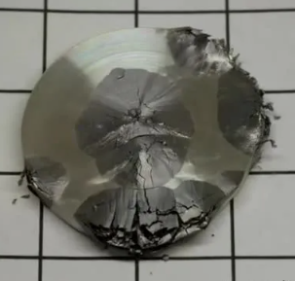
β-X |  | α-X
Another legend claims that Captain Scott’s Antarctic expedition failed because the kerosene cans were made of X. In the extreme cold, the β-X → α-X transformation caused the cans to crack, leading to kerosene leakage. The loss of fuel contributed to the explorers’ tragic fate.
Both allotropes react with concentrated hydrochloric acid, producing different volumes of hydrogen gas: V(H₂)_{α} = 188.7 cm³ and V(H₂)_{β} = 377.4 cm³ (0°С, 1 atm) per m = 1.00 g of α-X and β-X, respectively.
  - Identify metal X. Show your calculations. Write reaction equations 1) and 2) for the dissolution of allotropes α-X and β-X, respectively, in concentrated hydrochloric acid.
Note: If you have not identified metal X, use a relative atomic mass of 120 in further calculations.
Below are the thermodynamic data for α-X and β-X:
 | Δ_{f}H° (kJ/mol) | S° (J/(mol⸱K))
α-X(s) | −2.016 | 44.14
β-X(s) | 0.000 | 51.18
  - Determine the temperature T (℃) at which the transition β-X → α-X becomes spontaneous.
Allotrope β-X has a body-centered tetragonal crystal structure with a density of ρ_{β} = 7.3 g/cm³, while α-X has a diamond cubic crystal structure with a density ρ_{α} = 5.8 g/cm³. The unit cell of α-X is shown below; half of the X atoms form a face-centered cubic (FCC) lattice, while the others occupy its tetrahedral voids.
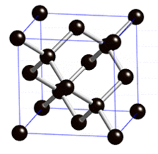
  - Calculate the increase in the volume ΔV/V (%) of a button from Napoleon’s army coat that occurred when exposed to low temperatures.
  - Calculate the lattice parameter a (pm) for α-X and the atomic radius r (pm) of X.
Allotrope β-X is mainly used as a non-toxic, corrosion-resistant coating. To protect steel parts from corrosion, a minimum thickness of allotrope β-X of d = 21 μm is required. This is achieved by electroplating steel cathodes in an acidic solution of Х²⁺ salts.
  - Calculate the electrolysis duration t (s) needed to achieve the required coating thickness if the cathode current density is j = 2.0 A/cm² and the current efficiency is η = 90%.
Addition of Bi³⁺ or Sb³⁺ ions during the electroplating process with X²⁺ solutions prevents the
β-X → α-X transformation in the coating. At the same time, the contact of β-X with α-X or binary compounds Y and Z at low temperatures catalyzes this transformation. Y and Z have crystal structures similar to α-X, with anions forming an FCC lattice and cations occupying half of the tetrahedral voids. Their lattice parameters (a) are also close to those of α-X.
  - Identify Y and Z if the mass fractions of their heaviest elements are 51.48% and 53.17%, respectively.

Problem 8. Metal as a workhorse catalyst
Metal X has high corrosion resistance and excellent conductivity, thus being widely used in the production of stainless steel, batteries and electronics. Complexes of X have attractive catalytic properties. One complex E can be obtained as shown below.
  - Determine the metal X and the compounds A-G if:
- During the transition BC one more signal at 1.06 ppm appears in the ¹H NMR spectrum.
- In D, ω(X)_{D}=11.04% and ω(Br)_{D}=15.05%.
- The ¹H NMR spectrum of E contains a signal with a chemical shift of -10.29 ppm and two signals in the aromatic region.
- There is no bromine in E.
- G is an oxide of the metal F (ω(O)_{G}=14.08%, F is found in the same group as X in the Periodic table of elements). G is widely used as a hydrogenation catalyst in synthesis.
If you failed to find the metal X, use X as its symbol in D and E.
  - Determine the coordination number (C.N.) of X in E. Select (only one) and fill in the appropriate energy diagram for metal X in E using the crystal-field theory.
Complex E reacts with CO₂ to form H.
  - a) Draw the structure of H if the C.N. of X is the same in E and H; the signal at -10.29 ppm in the ¹H NMR spectrum of E migrates to 8.62 ppm in that of H. b) Write the reaction equation.
In a CO₂ recovery plant, complex E can be used in the catalytic cycle where CO₂ in the form of bicarbonate is transformed into compound Z:
  - a) Find Z and b) write the reaction equation.
The installed capacity of the Syrdarya plant (the largest thermal power plant in Uzbekistan) is 3215 MWh per day. Assume that the combustion of coal is the main chemical process responsible for energy production in a thermal power plant.
  - Calculate the amount N (tons/year) of the metal X required to convert all CO₂ generated during the plant operation to Z (neglect the recycling of E). Δ_{f}Hº(CO₂) = -393.5 kJ/mol.

Catalytic systems of X work efficiently in nature. LarA is an enzyme responsible for the racemization of lactic acid, and X is found in its active site in an environment similar to that in E:
Recently, it has been suggested that racemization can occur through a proton-coupled hydride transfer from the lactate ion to the active center of the LarA via the formal mechanism:
  - Write the number of the amino acid residue that deprotonates lactate.
  - Write the number of the amino acid residue that protonates I₁.
  - Determine the species I, J, I₁, if the anion J has a plane of symmetry and two adjacent C=O bonds.
Two possible pathways have been proposed for the hydride transfer to the fragment with the metal X: through disruption of aromaticity (structure K₁) or through change of the metal geometry to tetragonal-pyramidal (structure K₂).
  - Draw the structures of K₁ and K₂.

